1. **Introduction:**

To transmit the student data to the Central Server for obtaining an authentication key to unlock the door for valid students using UDP.

1. **Scope:** Applicable for the Twinkle Door Access System
2. **The folder where the program resides and how to execute them from the start:**

In Local Server (Raspberry Pi, IP addr: 10.32.26.20):

**Location:** /home/pi/Desktop/Integrate_DB_UDP/Multiuser

**Name of the file:** UDP_Data_Store_DB_v3.py

**Dependent file:** UDP_Data_Connct_Cent_Serv.py

How to execute the program in Local Server:

* Open the terminal.
* Change the directory by typing:

“cd /home/pi/Desktop/Integrate_DB_UDP/Multiuser”

* To run the program type:

“python3 UDP_Data_Store_DB_v3.py”

In Central Server (Raspberry Pi, IP addr:10.32.26.70)

**Location:** /home/pi/Desktop/Integrate_DB_UDP/

**Name of the file:** UDP_Data_Store_DB_v2.py

How to execute the program in Central Server:

* Open the terminal.
* Change the directory by typing:

“cd /home/pi/Desktop/Integrate_DB_UDP/”

* To run the program type:

“python3 UDP_Data_Store_DB_v2.py”

1. **Guide to install the program and configure various parameters:** The program is a self-written script.

**Parameters to be configured:**

* In the Central Server:

1. In the program UDP_Data_Store_DB_v2.py, update the parameter: “list_valid_twinklet_for_twinkler1”,

For example: To provide the access for TwinkleT ID: 17,

Add “list_valid_twinklet_for_twinkler1= {‘17’}”

Every student has a unique TwinkleT ID, on updating the above parameter with the TwinkleT ID, only the valid students will get the authentication.

1. In the program UDP_Data_Store_DB_v2.py, update the port number in the main function accordingly.

**Note:**

For example: Port number=5002

Make the changes in line number 107:

“port=5002”

* In the Local Server:

1. In the program UDP_Data_Connct_Cent_Serv.py:

In the function client_program ():

Update the Central Server’s IP address and port number accordingly.

**NOTE: The port number in “UDP_Data_Store_DB_v3.py” of Central Server and port number in “UDP_Data_Connct_Cent_Serv.py” of Local Server has to be same.**

For example: If the Central Server is configured with port number=5002, then the local server should also be configured with the same port number=5002. If the Central Server’s IP address is “10.32.26.70”,

Make changes in line number: 18 and 19

“host=”10.32.26.70””

“port=5002”

1. **Detailed Description with diagrams:**

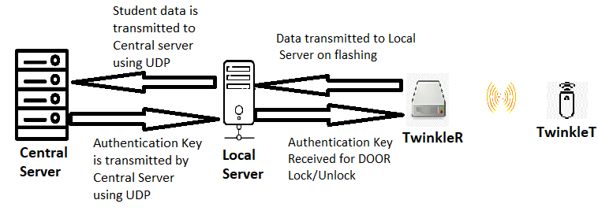

* On student flashing the device (TwinkleT) to the TwinkleR, the data is transmitted to the Local Server.
* Local Server in turn transmits this data to the Central Server.
* On receiving this data, the Central Server reviews the TwinkleT ID and if the ID is included in the valid list of TwinkleT’s, an “Open” Key is transmitted to the Local Server.
* The Local Server transmits it to the TwinkleR, for unlocking the door.

**Screenshots:**

**Central Server:** Terminal view on reception of valid TwinkleT ID:

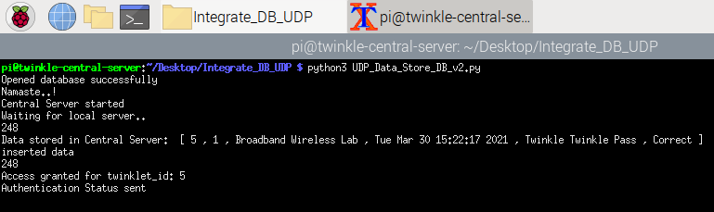

**Local Server:** Terminal view when a valid student flashes the TwinkleT:

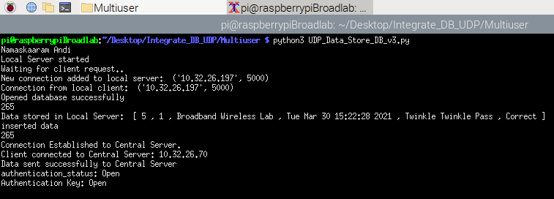

**Central Server:** Terminal view on reception of invalid TwinkleT ID:

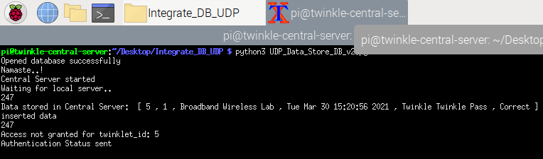

**Local Server:** Terminal view when a valid student flashes the TwinkleT:

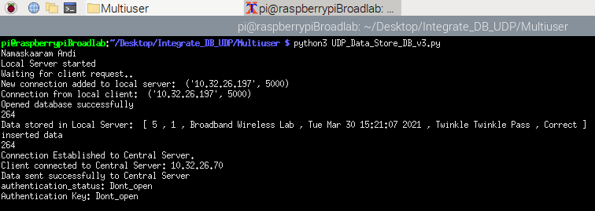

1. **Details about any scripts or 3rd party programs:**

No third-party program is implemented here

1. **Platforms required for running the programs (PC/RPi ...):**

Raspberry Pi, Windows with Visual Studio, PyCharm, Linux Systems.